**ACTIVITY 2**

**NAME : Abinaya COURSE: MOBILE COMPUTING**

**REG NO : 192421208 COURSE CODE: ITA0302**

2.Design a user interface prototype for a mobile station using Figma, considering

connectivity and convenience.

**Aim: -**

To create a user interface prototype for a mobile station using Figma, considering connectivity

and convenience.

**Procedure: -**

1. open Figma

2. Create a new file

3. Select the Frames

4. Design Visual Elements

5. Make it Interactive

6. Add icons on the Frame

7. Incorporate Multimedia

8. Storyboard Animation

9. Review and edit the Prototype

10. Save and Share

**Design:-**

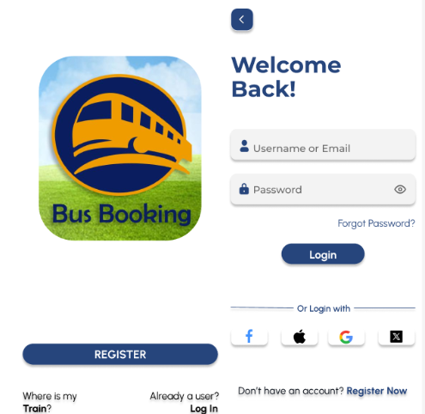 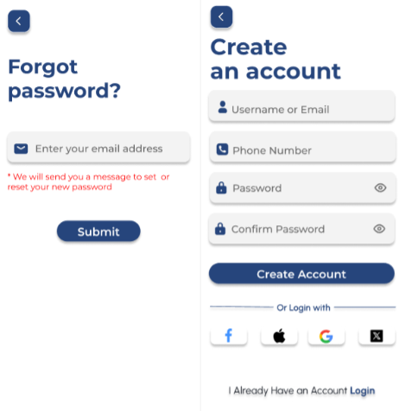

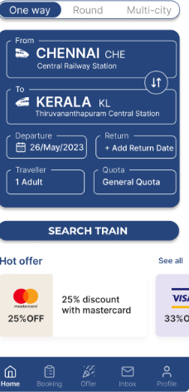 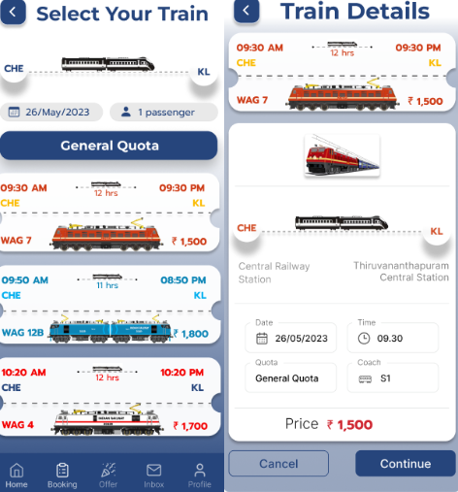 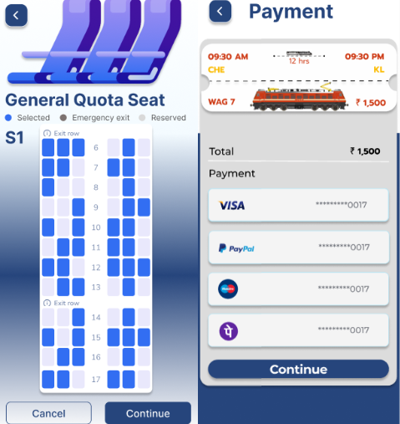 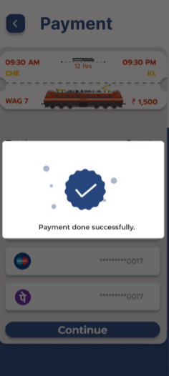 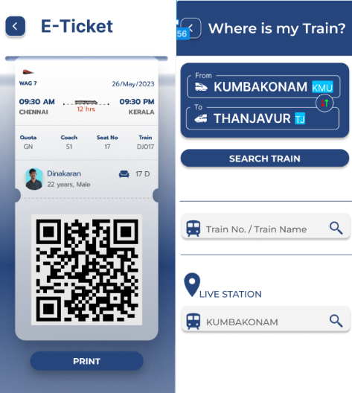 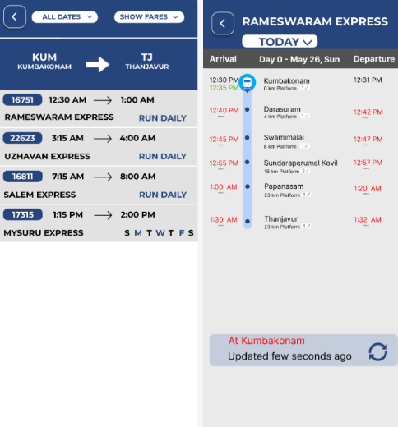

**Prototype:**

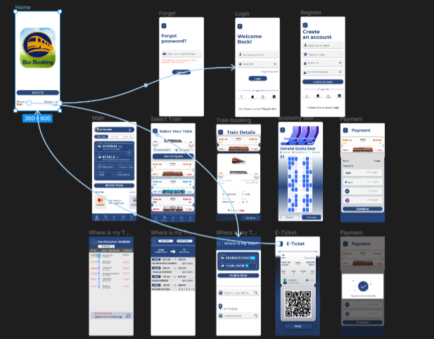

**Result: -**

A user interface prototype for a mobile station using Figma, considering connectivity and

convenience using Figma is created and executed successful